**Set up and learn about the Remote Work Management Solution in Power Apps**

A guide that helps you learn about and setup the remote work management solution that empowers managers and HR with insights about the employee’s attendance, progress, and locations wherever they were working from.

Guide prepared by:

Louay Karout – Power Platform Technical Specialist

Mohammed Rami Amcha – Business Applications SSP

Contents

**Set up and learn about the Remote Work Management Solution in Power Apps** 1

Solution Overview 2

Deployment Guide 3

Prerequisites 3

Create a home for your data 4

Create a SharePoint site 4

Create SharePoint lists for the app 6

Import the SharePoint list deployment flow 6

Run the SharePoint list deployment flow 8

Import and set up the Remote Work Service app 11

Import and set up the Remote Work Admin app 13

Import and Setup Employees List BI Dashboard App 14

Import the Alert When Late flow 14

Import the Create Absence Records deployment flow 18

Create Sample Data 23

Add your first employee 23

Configure your template 25

Edit the Remote Work App 26

Other Notes 29

# Solution Overview

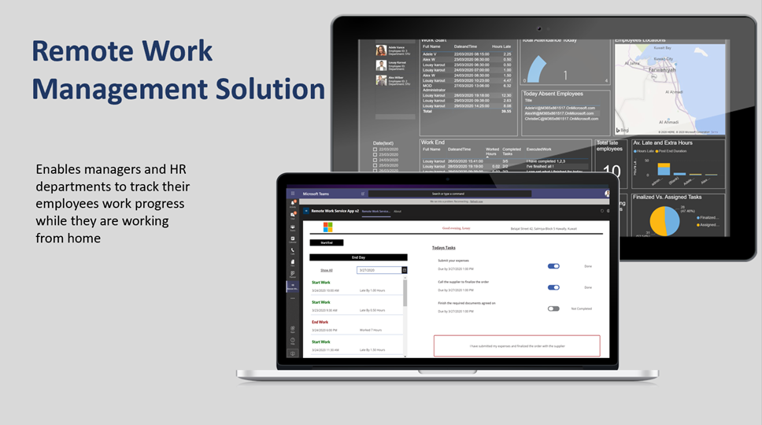

The **Remote Work Management solution** provides your organization with a set of capabilities to monitor your employees’ attendance, progress, and location wherever they are working from. Employees will be enabled with a smart application that tracks their start and end timings of the day and allows them to track progress against tasks assigned to them by management. The collected data will feed into an interactive dashboard, which will provide managers and HR departments with insights to take the right informative decisions.

**Capabilities for Employees:**

1. Employees can review their assigned tasks and log in the start of their workday.
2. Employees can mark their assigned tasks as completed, capture additional activities, and log the end of their workday.
3. Employees will be automatically notified by a bot if they haven’t started or ended their workday based on shift timings pre-configured by the organization.

**Capabilities for managers and HR :**

Pre-configured reports displaying team’s attendance and progress metrics such as:

1. List of employees absent today
2. Individual employees’ start time, end time, and ratio of completed tasks
3. Interactive map showing employees’ working locations
4. Employee-specific and average late hours, post-shift hours, and working hours
5. Total number of late employees

As the solution is built on top of the low-code Power Platform, it can be easily and seamlessly customized to fit your organization’s specific needs and have it running as soon a possible. Our team will be dedicated to help you with these customizations.

# Deployment Guide

In this walkthrough, you'll learn how to:

* Create a location for your data.
* Import both the Remote work Management app and its admin app.
* Import flows to Create SharePoint Lists , send notifications , and create absence records
* Create Employee Column in SharePoint Lists

Estimated time to complete these steps: **60 minutes**.

## Prerequisites

* [Sign up](https://make.powerapps.com/?utm_source=padocs&utm_medium=linkinadoc&utm_campaign=referralsfromdoc) for Power Apps.
* You must have a valid SharePoint Online license and permission to create lists.
* You must have a public SharePoint site where you can store the data for the app.
* You must have Power BI pro licenses or equivalent licenses that allows you to share reports
* Download the assets from [Github from here](https://github.com/louaykarout/RemoteWorkManamagement/upload)

## Create a home for your data

Data for the app is stored in SharePoint lists, so the first step is to create a new SharePoint site.

### Create a SharePoint site

1. Sign in to [Office online](https://www.office.com/), and then select **SharePoint**.
2. Select **Create site**.

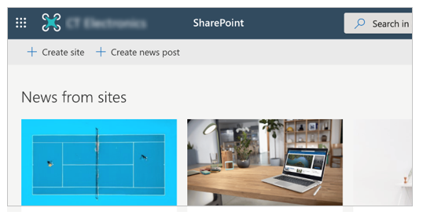

1. Select **Team site**.

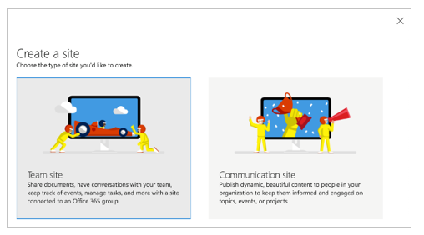

1. Enter a name and description for your site.
2. Set **Privacy settings** to **Public** so that everyone in the company can get the necessary information.

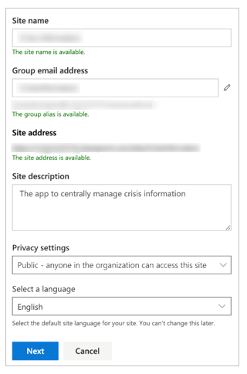

1. Select **Next**.
2. Add additional owners for the site (optional).
3. Select **Finish**.

## Create SharePoint lists for the app

The app uses multiple lists to store its data. You can use the Create SP List from flow, available from the downloaded [assets package](https://docs.microsoft.com/en-us/powerapps/maker/canvas-apps/sample-crisis-communication-app#prerequisites), to automatically create these lists.

### Import the SharePoint list deployment flow

1. Go to [flow.microsoft.com](https://flow.microsoft.com/).
2. Select **My flows** from the left navigation pane.
3. Select **Import** on the command bar.
4. Upload the **CreateSPListfromflow.zip** package from the package downloaded from GitHub repository.

1. Add a SharePoint connection for the new flow by selecting the **Select during import** link and completing the form.

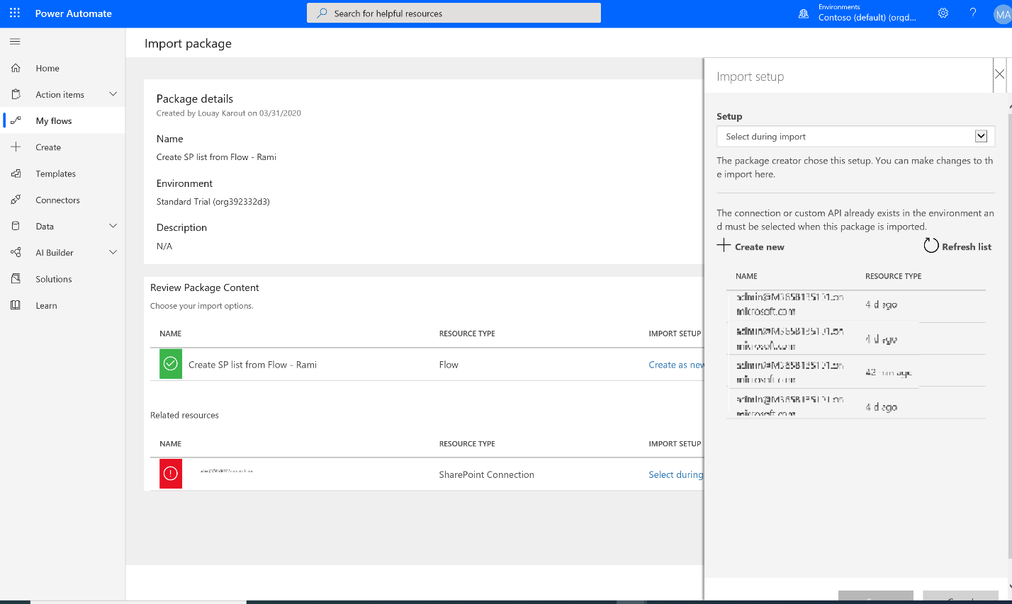

1. If you need to create a new SharePoint connection, select **Create new** in the **Import setup** pane.
2. Select **New connection** on the command bar.

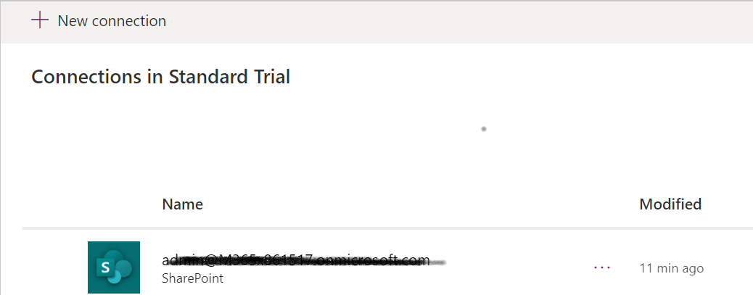

1. Search for the name of the connection, for example SharePoint.
2. Select the connection you created.
3. Select **Save**.
4. Select **Import**.

### Run the SharePoint list deployment flow

1. Go back to the detail screen for the Create SP List from flow.
2. Select **Run** on the command bar.

1. enter the name of your SharePoint site and click Run flow.
2. The flow creates the following SharePoint lists in your SharePoint site.

| **Display title** | **Description** |
| --- | --- |
| Admin_Records | To Store the start working time and end time of employee |
| Attendance_Records | To Store all the attendance records of the employees |
| Absence_Records | To Store all the absence records of the employees. |

1. Go to the SharePoint Site and open the Attendance_Records list.
2. Click on Add Column and press More… same as the image below:

1. Type “Employee” in the Column Name
2. Choose Lookup(information already on this site)
3. In the Get Information from choose : Employees
4. Click OK

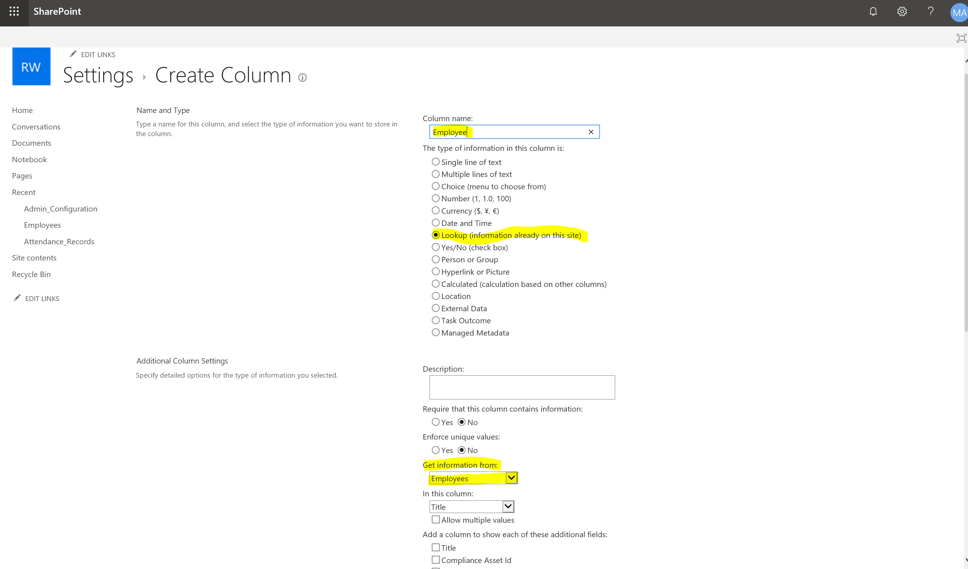

1. Repeat the above steps (step 6 to step 10) on the Absence_Records list.

## Import and set up the Remote Work Service app

1. Sign in to [Power Apps](https://make.powerapps.com/).
2. Select **Apps** from the left navigation pane.
3. Select **Import** on the command bar.
4. Upload the **RemoteWorkServiceAppNewList.zip** file from the package downloaded from GitHub repository.

1. Add a Bing connection for the new flow by selecting the **Select during import** link and completing the form.

For more information about getting a Bing Map key – please check this [link](https://docs.microsoft.com/en-us/bingmaps/getting-started/bing-maps-dev-center-help/getting-a-bing-maps-key)

1. Select **Import**.

## Import and set up the Remote Work Admin app

1. Sign in to [Power Apps](https://make.powerapps.com/).
2. Select **Apps** from the left navigation pane.
3. Select **Import** on the command bar.
4. Upload the **RemoteSolutionAdministratorApp.zip** file from the package downloaded from GitHub repository.

1. Press Import
2. Load the app in edit mode to reset connectors 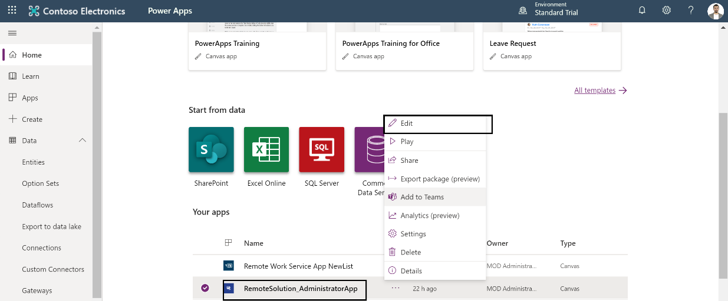
3. Remove the below connectors and add them again

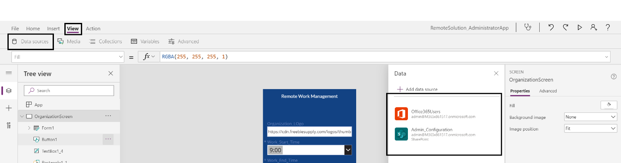

1. For the SharePoint Connector, choose under the list of data sources “**SharePoint**” --> Enter the SharePoint site URL created at the beginning of the document --> Select **Admin_Configuration** list
2. File->Save and **publish**
3. Close the application

Note: it is normal if errors are showing, those errors will be removed in the next load of the application due to the on start and on visible events of the app.

## Import and Setup Employees List BI Dashboard App

Repeat the above steps to install the Employees List BI Dashboard app that will be embedded in the Power BI dashboard to be set up later

This app utilized O365 connector that needs to be selected during import as above

## Import the Alert When Late flow

1. Sign in to [Power Apps](https://make.powerapps.com/).
2. Select **Apps** from the left navigation pane.
3. From the List , select the Remote Work Service App New List and press More Commands and press Details

1. Copy the App ID
2. Go to [flow.microsoft.com](https://flow.microsoft.com/).
3. Select Data 🡪 Connections🡪New Connection
4. Search for Power Apps Notification and click to select it
5. Paste the **App ID** from step 4 in the box and press Create
6. Select **My flows** from the left navigation pane.
7. Select **Import** on the command bar.
8. Upload the **AlertWhenLate.zip** package from the package downloaded from GitHub repository.
9. Add a SharePoint and Microsoft Teams connection for the new flow by selecting the **Select during import** link and completing the form

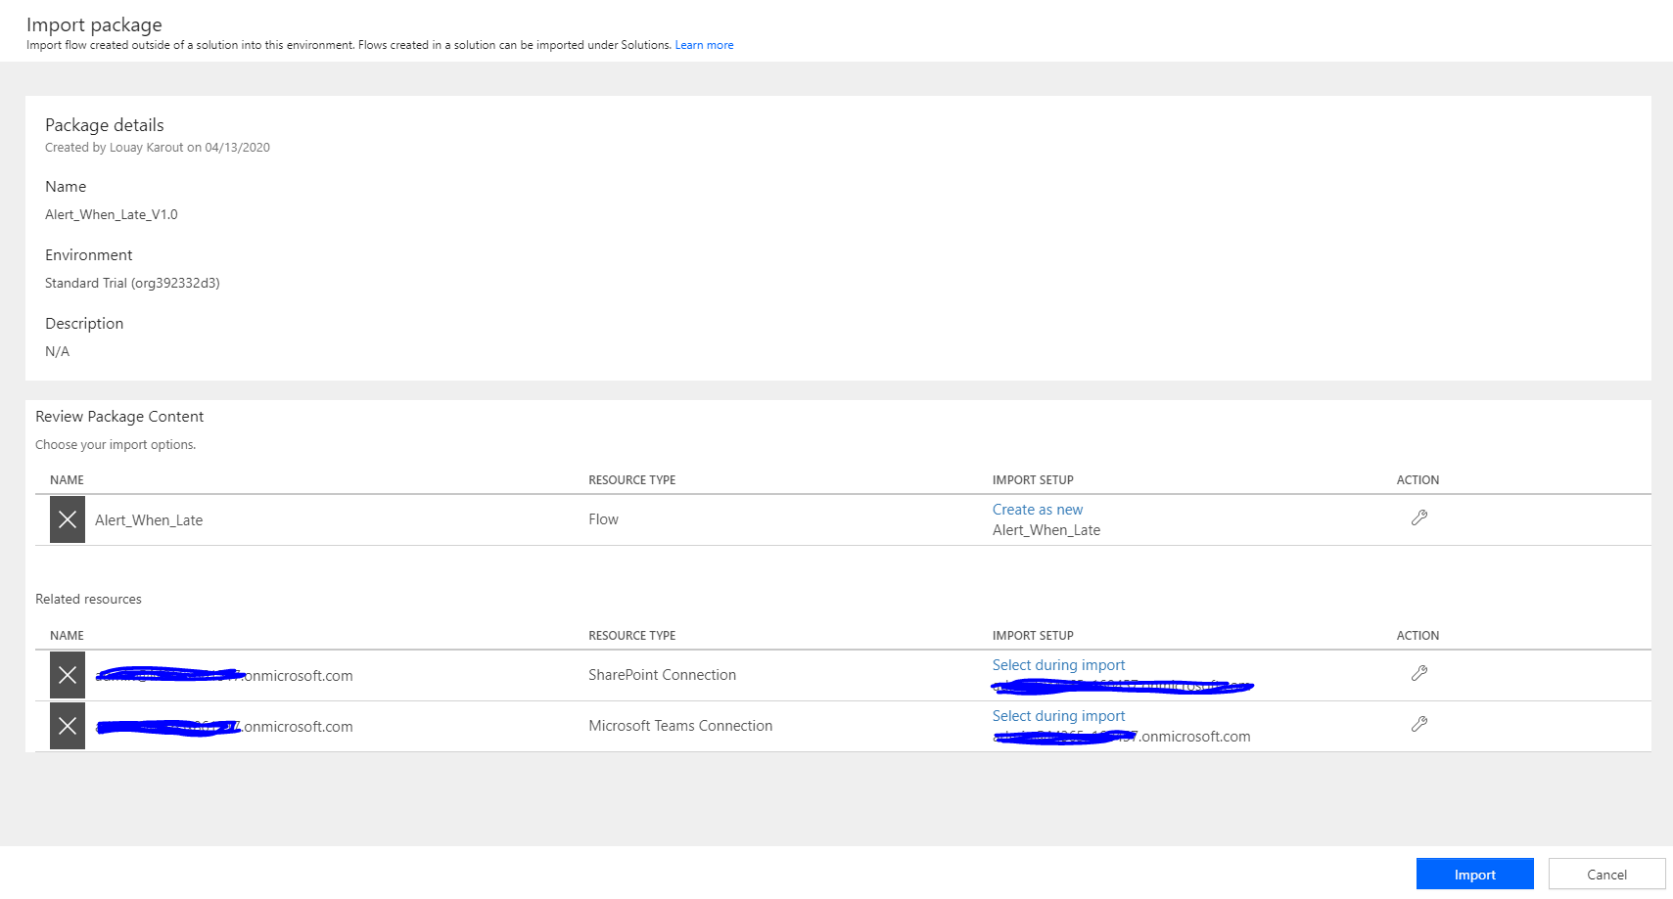

1. Press Import
2. Go to flow.microsoft.com
3. Go to My flows on the left Bar
4. Choose the Alert_when_late Flow and press Edit
5. Go to Get Items and clear the Site Address and List Name

1. Choose your Site Address and in List Name choose Admin_Confirguration
2. Scroll Down to the end of the flow
3. Expand the **grey icon** such as “Check if now in or post shift” to see the full view of the flow
4. Do the same for the GetEmployees as the image below and the other points listed below

1. Choose your Site Address and List Name Employees
2. Do the same for all SharePoint actions highlighted below :   
     
   GetAttendanceRecords Action -> Use **Attendance_Records** Sharepoint List

GetEmployees 2 Action -> Use **Employees** SharePoint List

GetAbsenceRecords -> Use **Absence_Records** SharePoint List   
GetAttendanceRecords3 Action -> Use **Attendance_Records** SharePoint List

GetAbsenceRecords 2-> Use **Absence_Records** SharePoint List

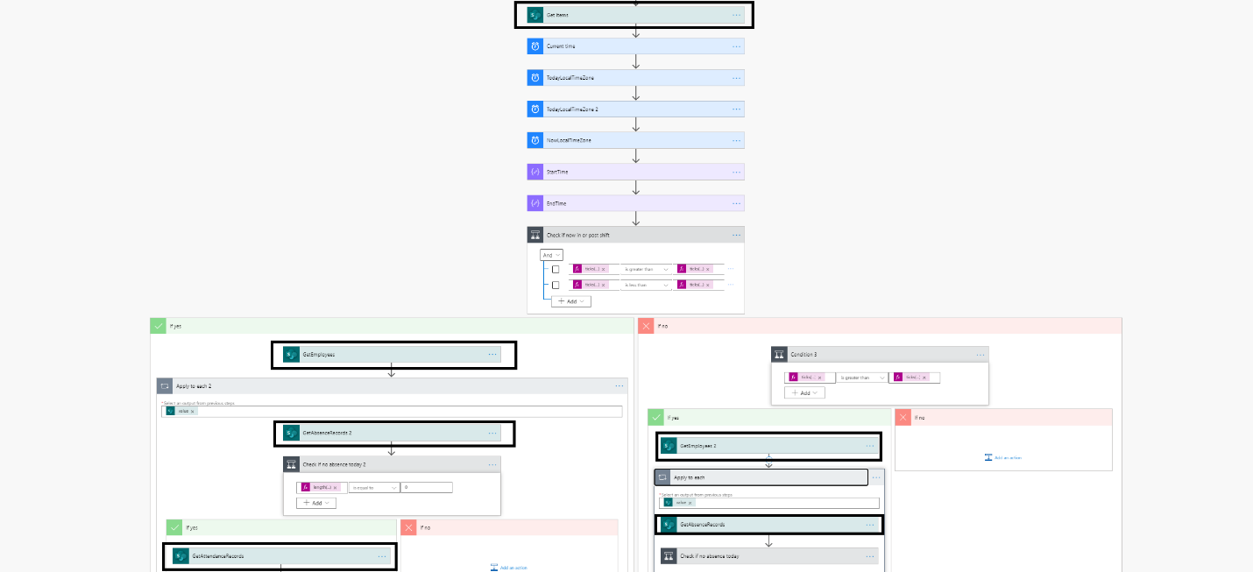

1. Press Save for your updates to take place

## Import the Create Absence Records deployment flow

1. Go to [flow.microsoft.com](https://flow.microsoft.com/).
2. Select **My flows** from the left navigation pane.
3. Select **Import** on the command bar.
4. Upload the **CreateAbsenceRecords.zip** package from the GitHub repository.

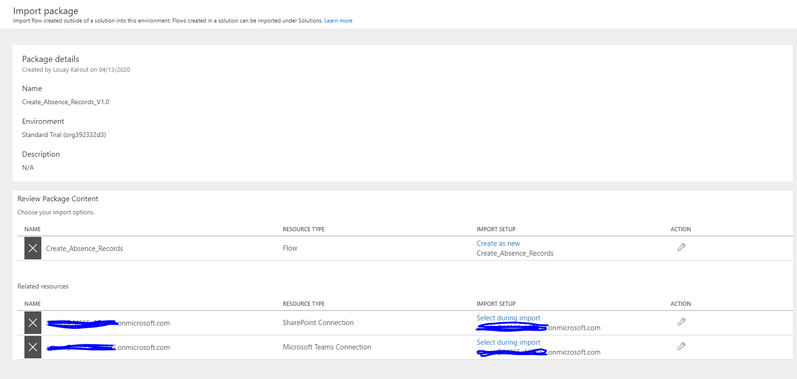

1. Add a SharePoint and Teams connection for the new flow by selecting the **Select during import** link and completing the form.

1. Search for the name of the connection, for example SharePoint.
2. Select the connection you created.
3. Select **Save**.
4. Select **Import**.
5. Go to flow.microsoft.com
6. Go to My flows on the left Bar
7. Choose the Create_Absence_Records Flow and press Edit
8. In Case you **need to change the time**, the solution creates an Absence Records for the employee that does not start the day please do steps14 and 15 (post that time, if employees did not start their days, they wont be able to start anymore and they are marked as absent). otherwise go to step 16:
9. Click on Recurrence and then press Advanced options.
10. Change at These hours to the time that needs to start counting from.

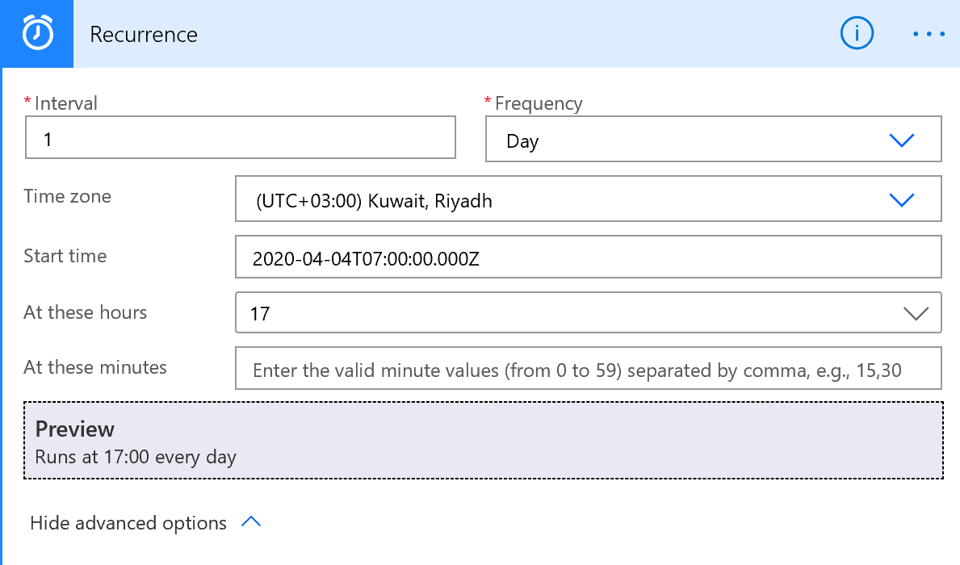

1. Go to GetEmployees and clear the Site Address and List Name
2. Choose your Site Name and for the List Name select **Employees**

1. Scroll Down to the end of the Flow
2. Expand the all the Grey steps such as “Apply to Each” and “Check if employee did not attend” to get the full view of all the flow
3. Choose GetAttendaceRecords and clear the Site Address and List Name
4. Choose your Site Name and List Attendance_Records

As well, change the lists for all of the Flow SharePoint Actions:

The above should be applied for all the SharePoint actions in the flow:

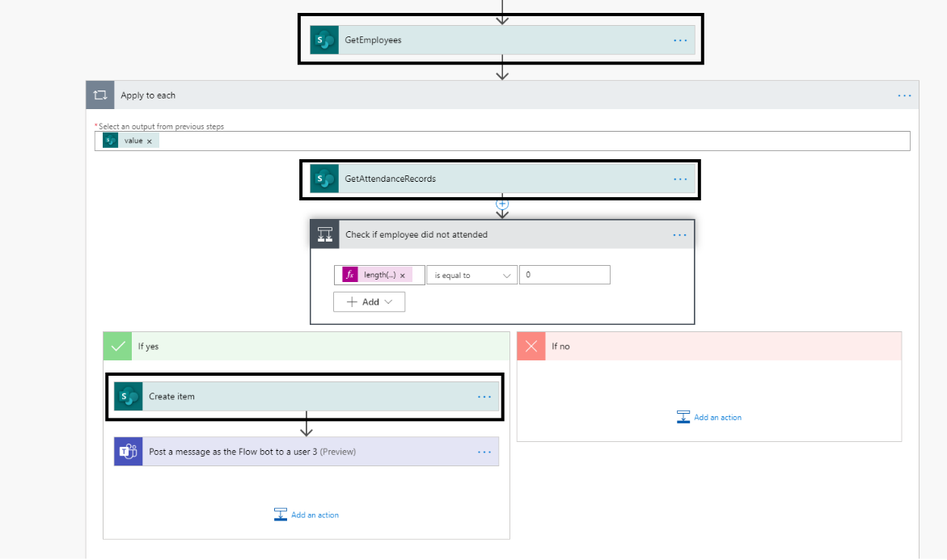

GetEmployees -> Employees List

GetAttendanceRecords -> Attendance_Records list

Create Item -> Absence_Records list

1. **Save** and Exit the flow

## Create Sample Data

### Add your first employee

1. Go to your SharePoint and Team Site
2. Choose Site Contents from the Left Navigation Pane
3. Go To Employees ListA screenshot of a cell phone

   Description automatically generated
   1. Press on the Employees List
   2. Press New

* 1. In the Title Section put the Employee email
  2. Fill the other information like Manager(Email) , Employee ID and Department.
  3. Press Save.

**Your accounts has to be part of the employees added above to continue in configurations and test the application**

### Configure your template

1. Load imported admin app

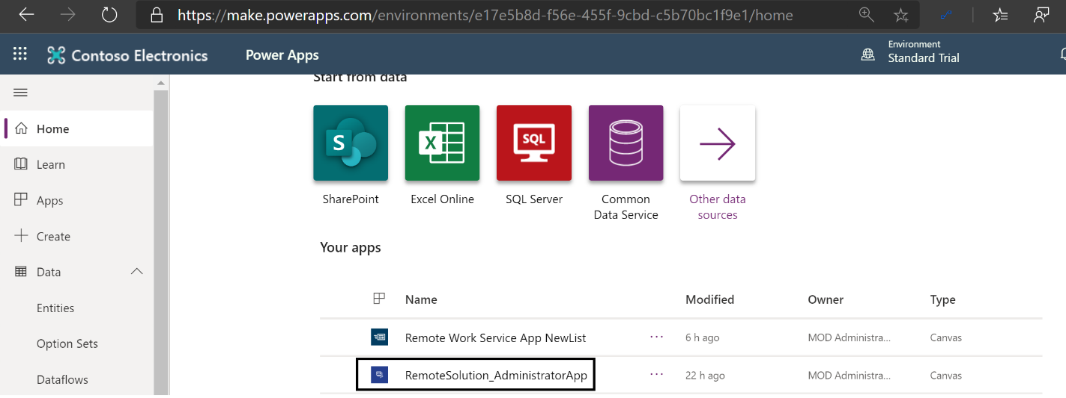

1. Select start and end time for your organization shift and a link for your organization logo. Click on Submit and make sure a new record is created in the SharePoint list Admin_Configuration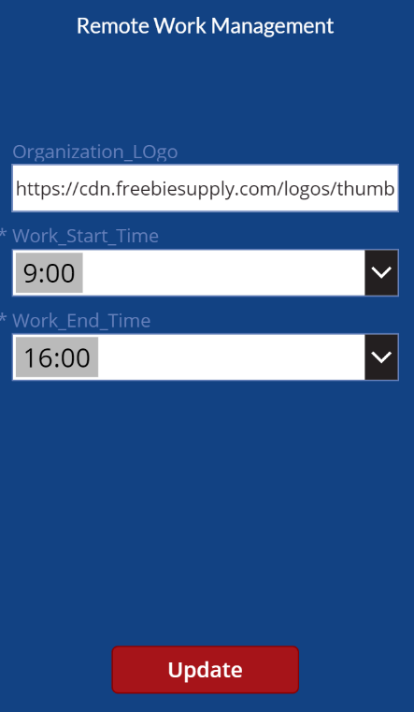
2. On your next load of the application, the previous data should show up on the form as default values that you can overwrite

## Edit the Remote Work App

* + 1. Sign in to [Power Apps](https://make.powerapps.com/).
    2. Select **Apps** from the left navigation pane.
    3. A screenshot of a cell phone

       Description automatically generatedChoose Remote Work Service App New List and press Edit
    4. Sign in or create any necessary connections, and then select **Allow**.
    5. Go to the data sources in the left pane.

* + 1. Remove existing SharePoint lists inside the app, because they don't point to your current SharePoint site.

* + 1. Add the lists from your own SharePoint site. Start by searching for **SharePoint** in the search bar.

* + 1. Select **SharePoint**, and then choose a connection.

* 1. Copy and paste the URL to your SharePoint site in the text field, and then select **Connect**.

* 1. Select all SharePoint lists and libraries, and then select **Connect**.
  2. Save your application (file->save) and publish
  3. Refresh the session and open the application again to make sure load actions take effect

## Embed in Microsoft Teams

For the ease of use of the application, and to enable employees with a seamless experience, the application will be embedded in Microsoft Teams. To configure that, please follow [this guide](https://docs.microsoft.com/en-us/powerapps/maker/canvas-apps/embed-teams-app) and apply it on the remote management service power app.

## Configure Power BI Report

1-Open the Power BI file present in the downloaded solution package by using Power BI Desktop

Install Power BI Desktop from the Windows app store: <https://aka.ms/pbidesktop>

2- click on transform data

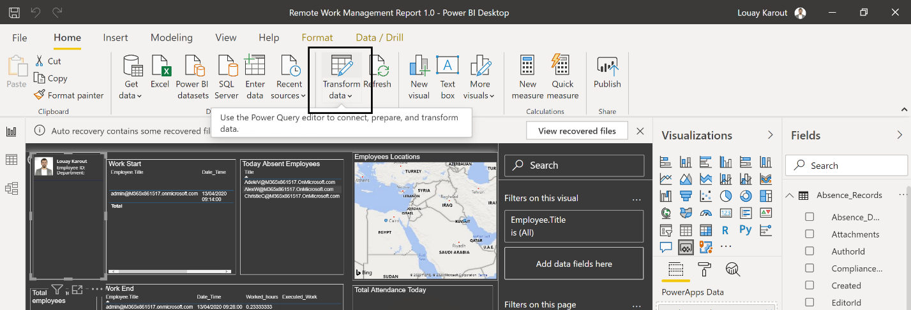

1. Select data source settings

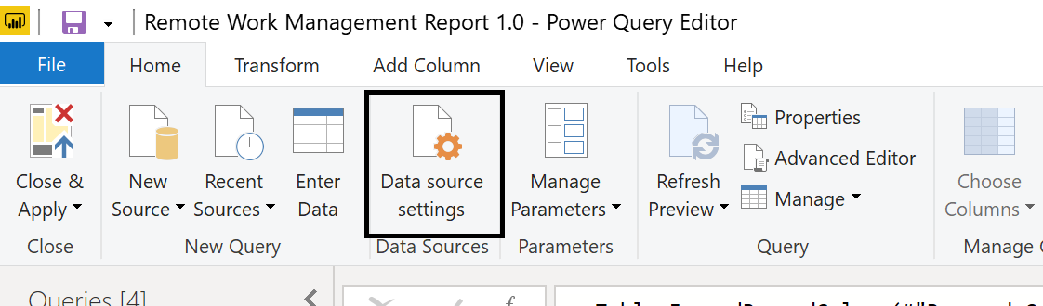

1. Click on change source and put the SharePoint site URL

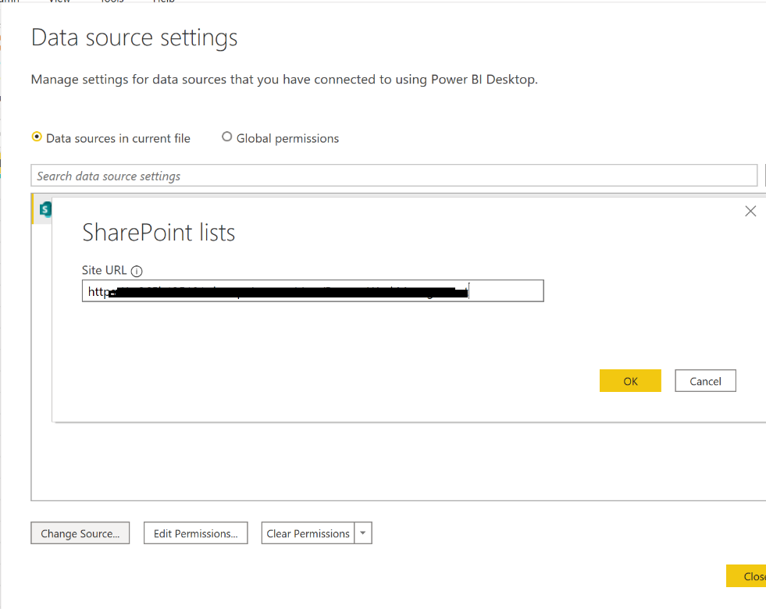

1. Click edit permissions

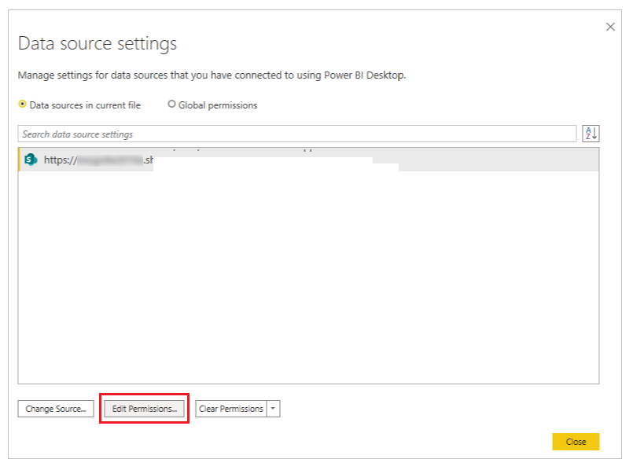

1. Ensure the Credentials type is set to Organizational account, and use the credentials to access the SharePoint list.

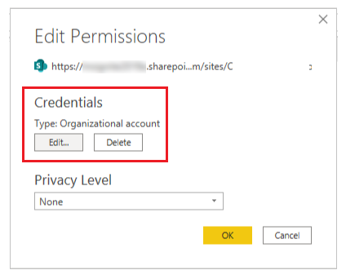

1. Sign in with your organization credentials that have access to the SharePoint Site
2. The connection with the current queries should break like the following :

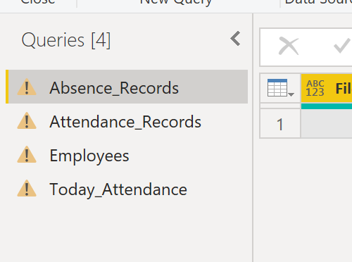

1. Right click on the first query and click on advanced editor

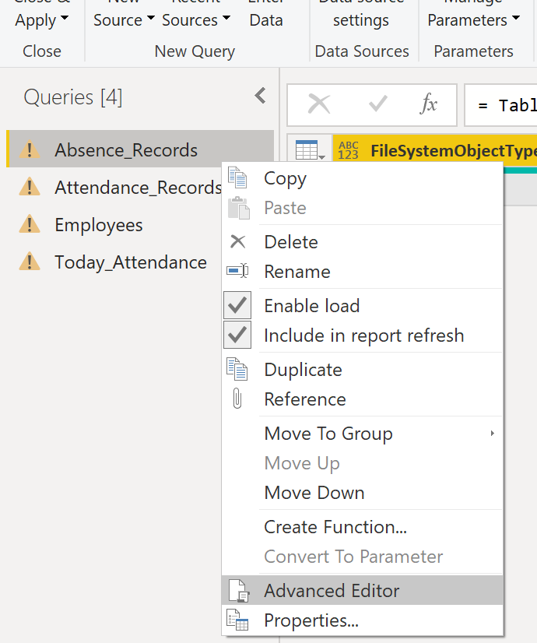

1. Replace the list id with the Attendance_Record list id in your SharePoint site

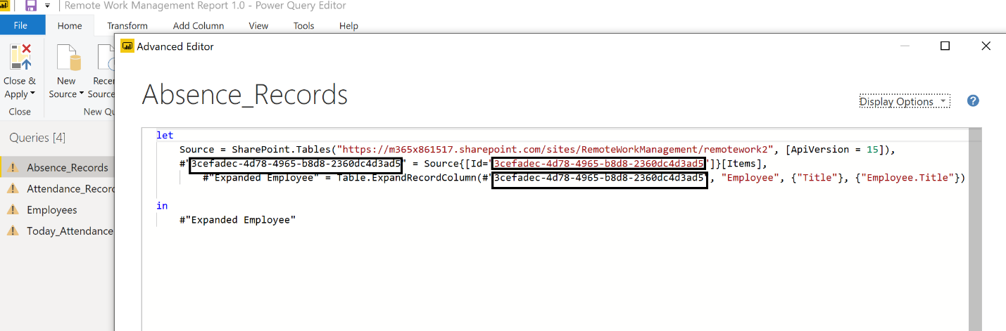

Note that the sharepoint list id is found in URL when you open the list settings without 7B and %7D

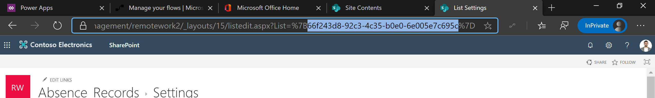

1. Do the same for attendance_records

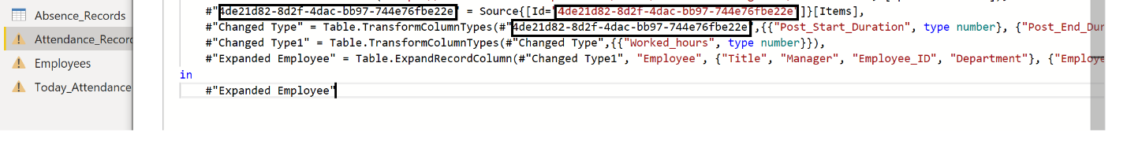

1. Apply the same steps for the Employees Query
2. Open the Today_Attendance query in the advanced editor
3. Change the list id to the id of attendance_records list (captured above and put in the attendance_record advanced editor)

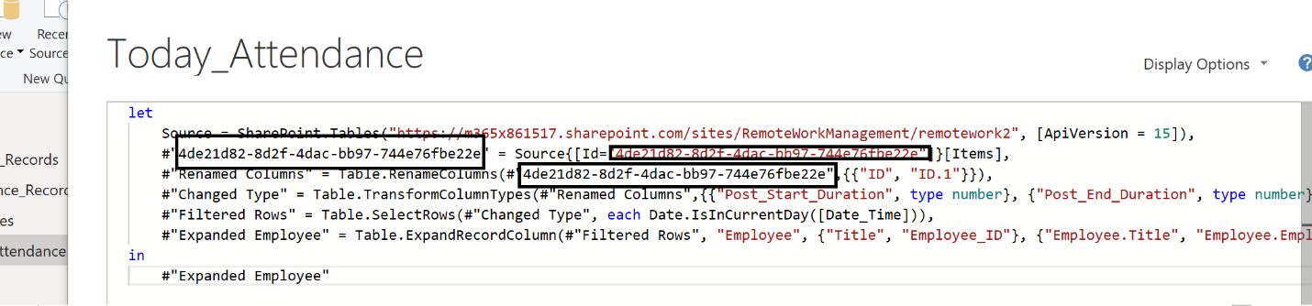

1. Warnings should have disappeared from queries – click on Close & Apply

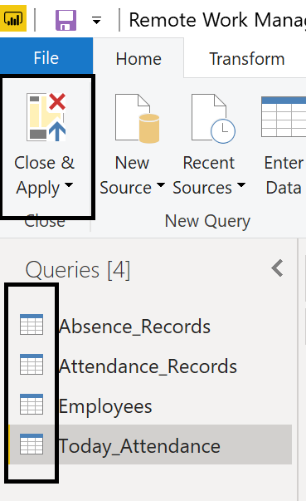

1. Remove the embedded canvas power app from your dashboard

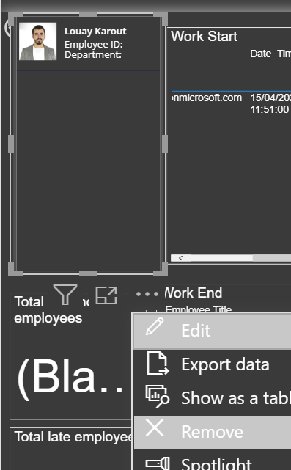

1. Add a new power app form the visualizations instead while selecting employee.title field from the Today_Attendance dataset in the visual inside the Today’s Insights page and employee.title from the attendance_records dataset in the visual in History page of the report 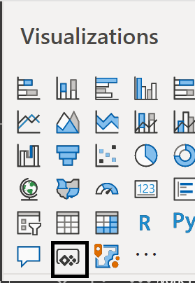 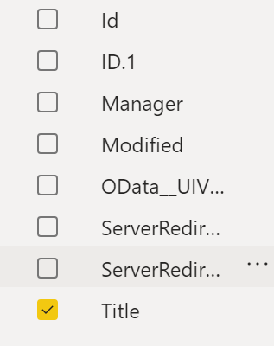
2. Select choose app from the visual

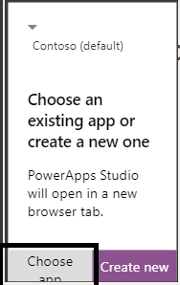

1. Select the app Employees_List_BIDashboard

## Share Power App

After finishing the deployment, it is time to share your power app application. For that purpose, please follow [this guide](https://docs.microsoft.com/en-us/powerapps/maker/canvas-apps/share-app) to share the remote work power app for your employees to use it.

Applications can be shared with Office 365 groups.

## Other Notes

1. After deployment, you would need to share the remote work power app with your employees,
2. In case SharePoint list does not show up in the list picker in Flow, try entering the site name manually
3. For your time zone to apply, make sure to amend all time zone actions called in the Alert_When_Late Flow

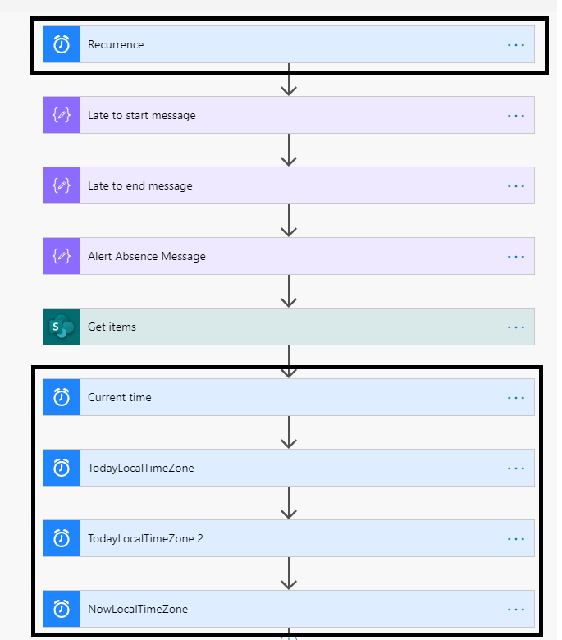

1. The solution currently does not create absence records or alert when late on weekends (configured currently Sunday-Thursday). In case you want to amend those days, this has to be configured for the flows recurrence action (the first action on both flows : alert_when_late and create_absence

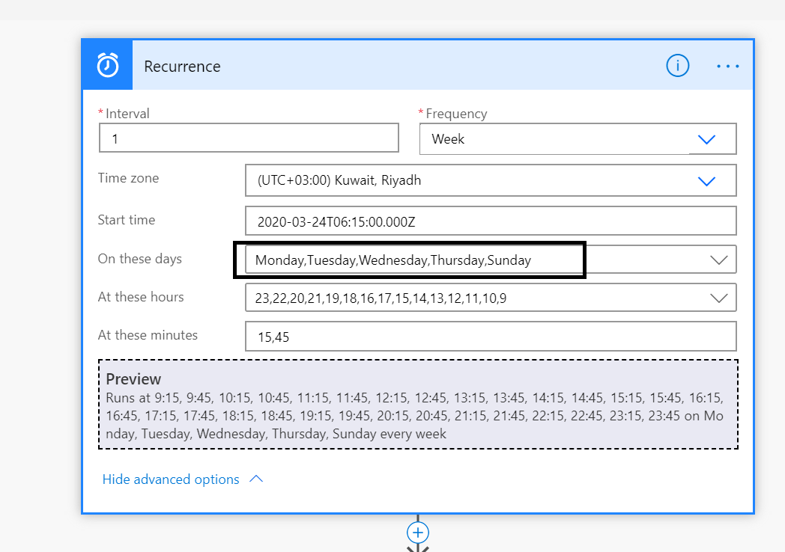

1. Teams notifications are configured for alerts. In case you need to enable mobile push notifications, this can be done by following [this guide](https://docs.microsoft.com/en-us/powerapps/maker/canvas-apps/add-notifications). Push notifications is a premium feature but currently exempted from premium licenses. Using it might require power apps licenses on a later stage that provide you access to all premium connectors and features as well [as common data service which is a key component in building line of business apps.](https://www.linkedin.com/pulse/why-common-data-service-your-business-apps-louay-karout/?trackingId=iVzHknqZS%2BCV1auCoccMwA%3D%3D)